GAS Implementing Health Bar UI

This documentation will introduce delegates in C++ and how to access the attribute set.

# Step 1: Creating a Dynamic Multicast Delegate

In the *AttributeSetBase.h*we declare an dynamic multicast delegate for broadcasting later.

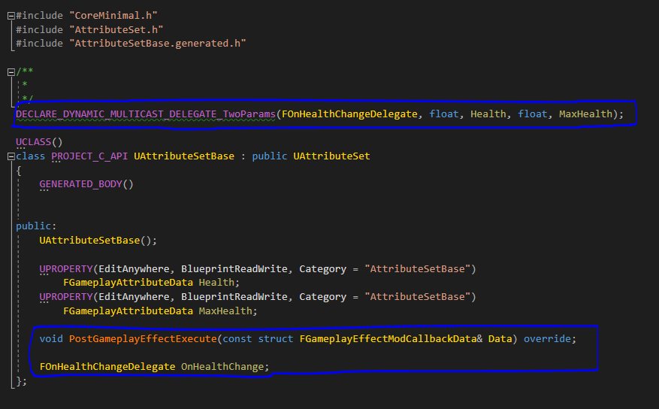

We then override the function *PostGameplayEffectExecute()* and a new variable *OnHealthChange* of type *FOnHealthChangeDelegate* that what we just created. Now inside the cpp file, we evaluate if the health property is being changed. If so, we proceed and broadcast.

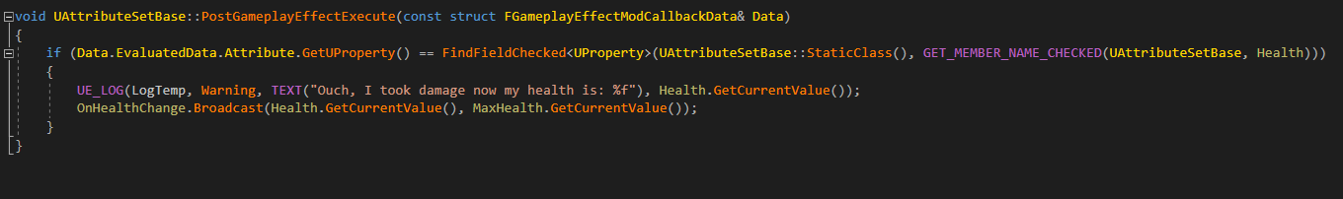

Inside the cpp file be sure to include the following headers:

* GameplayEffectExtension.h
* GameplayEffect.h

# Step 2: Implement in Player Character Class

Inside of the *PlayerCharacter.h* we will create two new function.

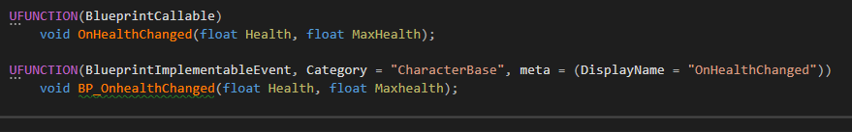

We then will go to the *PlayerCharacter.cpp* and add the multicast delegate to the desired function which will be our *OnHealthChanged*. We will be adding this inside the *BeginPlay()*function.

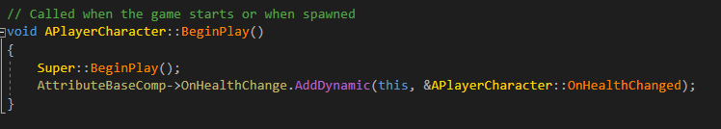

We will then implement the function *OnHealthChanged()*

